ACT 3 NEW USER’S GUIDE

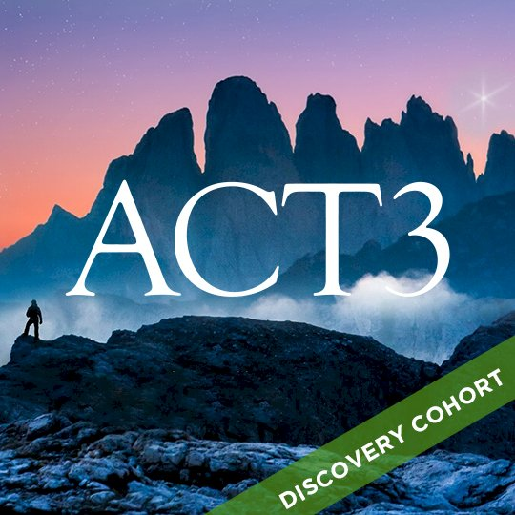
Pam Givens
ACT 3 Ministry
pamgivens@act3ministry.com
Now What?
You have finished discovering your unique strengths, spiritual gifts, the people that have helped shape you and the resources that you have gathered along your journey. Now it is time to implement your uniquely designed calling and purpose for your own life. Get connected is a great tool to do just that. You will set up a profile, fan causes and select skills that align with your calling. As opportunities are available, you will receive an email that allows you to respond to that need and get connected to your community serving in alignment with your unique calling.
Ready to set up an account on a Get Connected?

Visit Home (act3ministry.com).
Select ACT 3 Serving Opportunities
Select Volunteer Now
or

Scan the QR code to begin to set up your account.
- Create an account by entering your personal information.
Begin by going to your local Connect site and clicking the Sign Up button, located at the top of your screen.
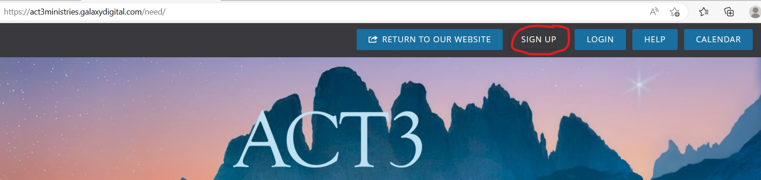
You are then taken to the first step, Create Account.
- Enter your name, email address, and any other requested or required personal information. (If you want to sign up using your Facebook account)
- Type a password in both the Password and Confirm Password fields.
Note: Passwords must be at least eight characters long and are not case-sensitive. Most Connect sites do not require a combination of letters, numbers, and special characters.
- Click Create Your Account.
- Make sure you select that you want to receive emails to know about opportunities that match your skills!

- Select Causes you are passionate about.
For this next step, you're asked to indicate the causes you're passionate about. This information will help your Connect site inform you of the agencies in your community that support the same causes.

Causes are displayed with their icons in a grid similar to the example shown below. When you select a cause, it will be highlighted with a heart.
Click the button to Continue.
- Select Interests or Skills
For this next step, you're asked to indicate your volunteer interests, to include the all the skills and talents you can use in volunteering. This information will help your Connect site inform you of the volunteer opportunities in your community that match your interests and could use your skills.

Without Skills selected the connection site cannot match you with needs, the more the skills you select the more needs you will be matched with.
Interests are displayed with their icons. When you select a cause, it will be highlighted with a heart.

Once you have selected at your interests, click the button to Continue.

- FAN the agencies that align with your causes
You'll want to fan any agencies that you're interested in supporting through volunteerism. Once you've fanned an agency, you'll receive emails whenever that agency posts new opportunities or events.

To fan an agency, click on it. Once you've selected it, the agency box is highlighted and shows a heart.

Once you have fanned one or more agencies, click the button to Continue.

You can always fan an agency later by:
- Go to the agency's profile page. (You can find an agency's page by clicking Agencies in the navigation menu and searching for the agency. Note that some admins may use the term Organizations rather than agencies.)
- Click the Become a Fan button. The button text changes to read Fanned.

Once you have become a fan, the text of the button will change to show that you have fanned the agency. If you want to "un-fan" the agency, click the Fanned button on the agency card.
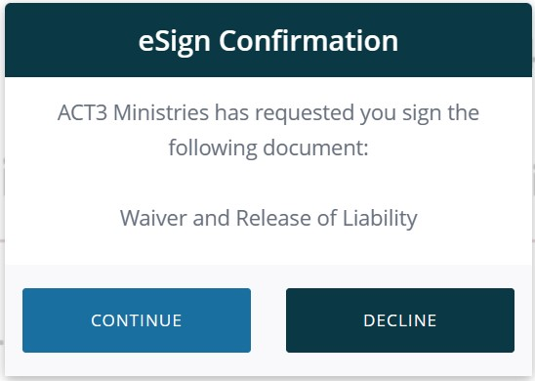
- Qualifications
- Select Waiver and Release of Liability
- Select Continue.
- Electronically initial each statement, sign, and date the waiver.
- Select Complete signing

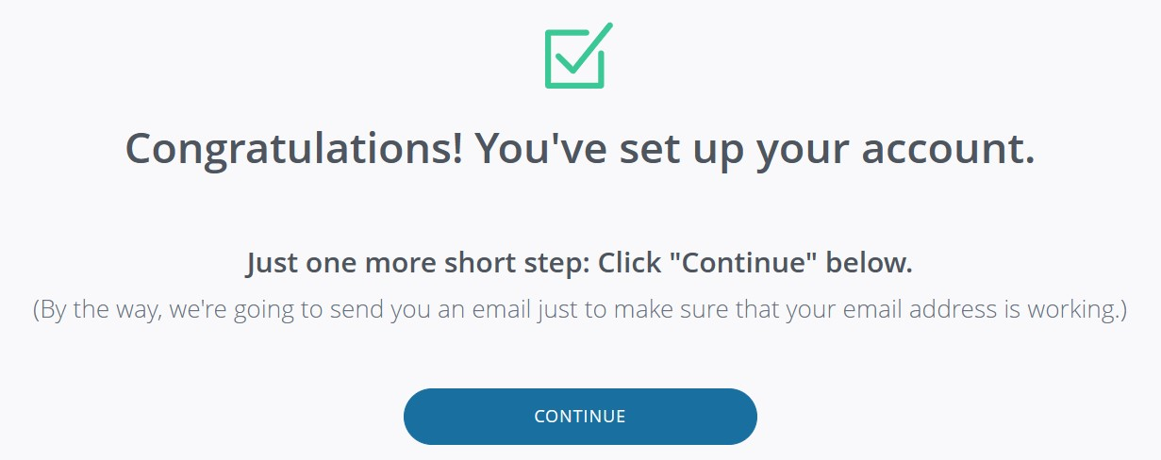

The Volunteer Dashboard
Your volunteer dashboard is your "home page" for your Connect platform. It contains all kinds of information to help you find volunteer opportunities, view your past volunteer efforts, and see what's going on with the nonprofits in your community!
Volunteer Snapshot
Your personal volunteer stats are shown at the top of the dashboard, includes:
- Your total number of approved, pending and entered volunteer hours
- A link to your volunteer resume
- Impact value of your volunteerism
- Number of agencies you've fanned
- Number of events to which you've RSVP'd
- Number of needs to which you've responded
- Breakdown of your volunteer hours by skill
Note: Impact value is calculated using your state's value of volunteer time
Click on the table to access more detailed information, as follows:
- Click the number of Volunteer hours to access your Track Hours page, where you can view previous hours and add new ones.
Note: You can also access the Track Hours page by clicking on the Impact Value area of the dashboard.
- Click the Agencies Fanned area to see what agencies you've fanned. From there, you can click on an agency to visit its profile page.
- Click the Events RSVP'd area to be taken to a list of all events posted on the site.
- Click the Need Responses area to view a list of all needs posted on the site.
- Click the Volunteer Resume link to view your volunteer résumé.

Suggested Needs
Suggested needs are based on your interests, as entered in your profile and/or when you first joined the site.
Note: To manage your interests, go to My Profile (top right) or Résumé and scroll to the Skills section. Click the Manage Skills button, and then add or delete interests as desired. Click Update Skills to save the new information.
Latest Events

Your dashboard includes information about the most recently added needs, events, and agencies. Click the View More or View All buttons to see a complete list.

Our Community
Here you can view pictures uploaded of those in our community of volunteers.

Recent Opportunities
Recent opportunities that have been added will appear here. You can scroll down and Select
View more opportunities to see a complete list.

Recent Programs
Programs with recent changes will appear here. You can scroll down and select View all programs to see a complete list.
Finding Volunteer Opportunities
From your Volunteer Dashboard
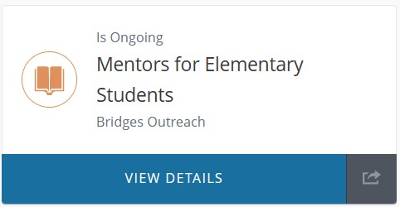
From the menu bar to the left select Opportunities.

All opportunities will be shown like the image here:
To view more information about the opportunity, select View Details.

From the View Details page, you can find out all the details:
- Frequency of the opportunity
- Hours
- Specific requirements
- Hosting program with the ability to fan that organization
- Location
- Skills requested

From your local Connect site.
Go to the Get Connected site. ACT3 Ministries (galaxydigital.com)

Click Volunteer Now to view a page listing the most recently posted volunteer opportunities on the site.

If you're logged in, you'll be taken to your volunteer dashboard. From there, follow the above instructions.

To search for an opportunity.
You will be able to view the volunteer opportunities by Grid, List, Calendar, or Map. Select your view by clicking one of these selections:

Bear in mind that volunteer opportunities that are ongoing or run until a certain date will not show on the Calendar view.

Searching by Phrase or Keyword
Use the Search By field to search opportunities by phrase.
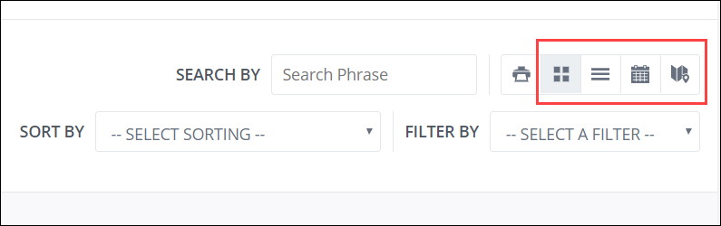
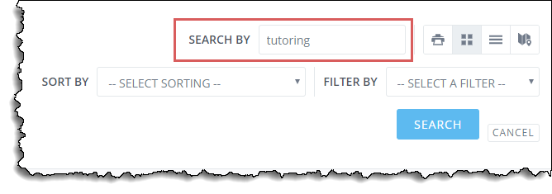
Press the ENTER key or click Search to see your results.

Sorting Opportunities
By default, opportunities are listed with the more recently added or updated need first. To change this order, use the Sort By dropdown to sort needs by newest first, oldest first, alphabetically, or soonest first.
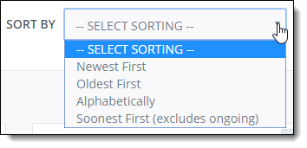
Note: If you sort by soonest first, the system will only show those opportunities that are associated with a date; it will not include ongoing needs.

Filtering Needs
From the Filter By dropdown, you can select to filter opportunities by the criteria shown below.
Once you've selected a filter, you'll be prompted to enter or select criteria to narrow the filter. For example, if you select skill, you'll need to also select a skill. Click Search to see all opportunities associated with the skill you selected. Filtering options are described below.
Filter Option | Description
Age | Select Age, and then enter your age (or the age of the volunteer, if you're searching for needs for someone else). Click Search to view all needs that have an age range that includes the age you entered, as well as any needs that have no age range specified.
Program | Select Program, and then select an agency from the dropdown that appears. Click Search to view all active needs that have been posted by that agency.
Available Slots | If you are responding as a team, you can filter for needs with enough spots to accommodate your team size. Select Available Slots, and then add in the number of people on you team.
County | Select County, and then select a county from the dropdown that appears. Click Search to view all active needs that have been posted for that county. (Your Connect site determines county by the ZIP code associated with each need.)
Date | To find needs that occur on a certain date, select Date and then select a specific date from the dropdown that appears. Only those dates associated with active needs will be available for selection. Click Search to view all needs for your selected date.
Distance | To find needs within a certain distance of a ZIP code, select Distance. From the dropdown that appears, select the mileage, and then enter the ZIP code in the next field. Click Search to view all needs within the selected number of miles of that ZIP code.
Family Friendly | When posting a need, an agency can specify whether the need is family-friendly. To find family-friendly needs (or to find needs that are not family-friendly), select Family Friendly, specify whether or not you want to see family-friendly needs, and click Search.
Impact Area | If your site uses impact areas, you can search needs by impact area. If your site does not use impact area, this option will not be available.
Skill | To view for the needs that best match your volunteer interests, select skill, and then select a specific skill from the dropdown that appears. You can search for one interest at a time.
Outdoors | Looking for needs that are specifically indoors or outdoors? Select Outdoors, and from the dropdown that appears, select whether you want to view indoor or outdoor needs. Click Search to view your results!
Teams | It's easy to find team opportunities with the Team search. Just select Teams and then specify that you want to view needs that accept team signups. (Or select that you want to see needs that only accept individual signups.) Click Search to see the needs that match your criteria.
Virtual Opportunity | These are needs that can be done remotely, either online or from home.
Wheelchair Accessible | Use the Wheelchair Accessible option to find all needs that are wheelchair-accessible.

Responding to Volunteer Opportunities
- Click the Respond button, located in the top right-hand corner of the need-information page.
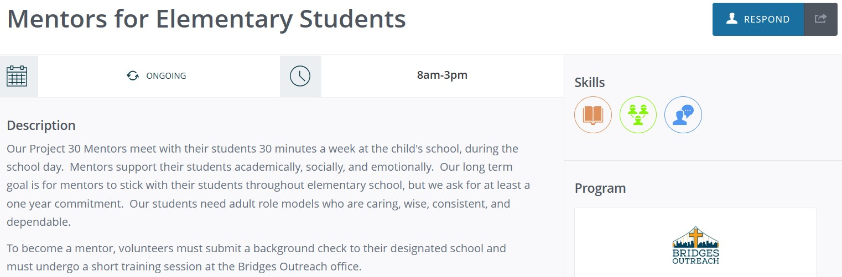

- On the response page that is displayed, you can type any additional notes for the agency manager. If other questions have been added for this need, you may be required to answer them.
- Click Submit Need Response.

You are returned to the need-information page, and the Respond button is replaced by an Unregister button.
You'll also receive an email confirmation of your need response, and the agency manager for the need will be notified that you have signed up.
You can unregister from a volunteer opportunity as long as the opportunity is in the future. You will find the opportunity as before and select Unregister.

Logging Your Volunteer Hours
You can use your Get Connected site to log all of your volunteer hours. Hours show up on your volunteer résumé, and they can be used by the nonprofit later on to strengthen requests for funding and other support. So remember to log your hours!
Note: It is not necessary to log your hours if you checked via a kiosk or App
From your local Connect site.
- Log into your Get Connect site. ACT3 Ministries (galaxydigital.com)
- Click the Add Hours button at the top of your screen to open the Track Hours page.
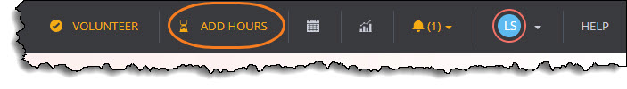
Note: Alternatively, you can click on your profile dropdown (located where the blue circle is in the image above) and select Track Hours, and then click Add Hours, located under the Volunteer Hours heading.
- Click Yes under the Hour Type heading. (By clicking Yes, you indicate that the hours you're posting are related to a need you responded to previously on your site.
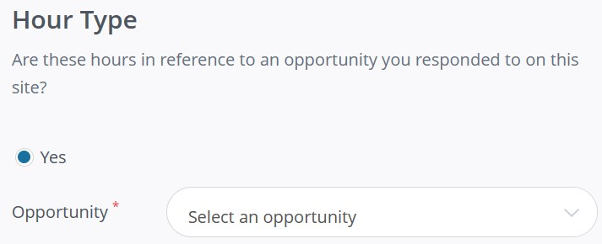

- Select a need from the Opportunity dropdown.
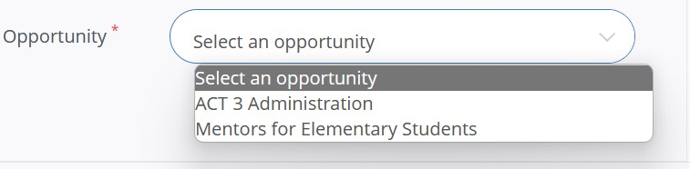

- Enter the hour details, including the date and number of hours.
- Complete all other Hour Details fields that apply.
- (optional) If other people who are not registered volunteers joined you for the volunteer opportunity, you can add plus-one hours to account for their time. If you select the Yes radio button, you will see additional questions.

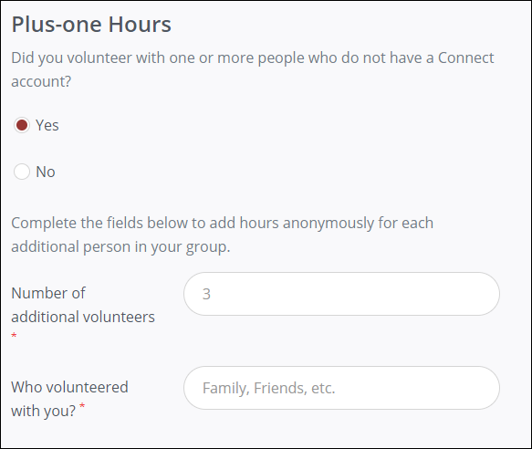

I Downloaded the App. Now What?
Finding and responding to volunteer opportunities can be accomplished right from your phone or tablet with the CauseConnect app!

How do I access the app?
First, you need to download the app from your phone or tablet's app store. Open up your app store and search CauseConnect.
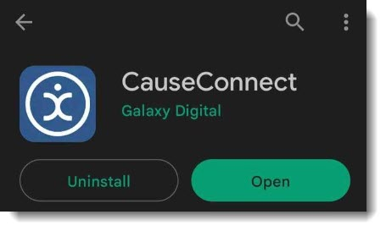
- You can also scan these QR codes for your specific device to download the app now!
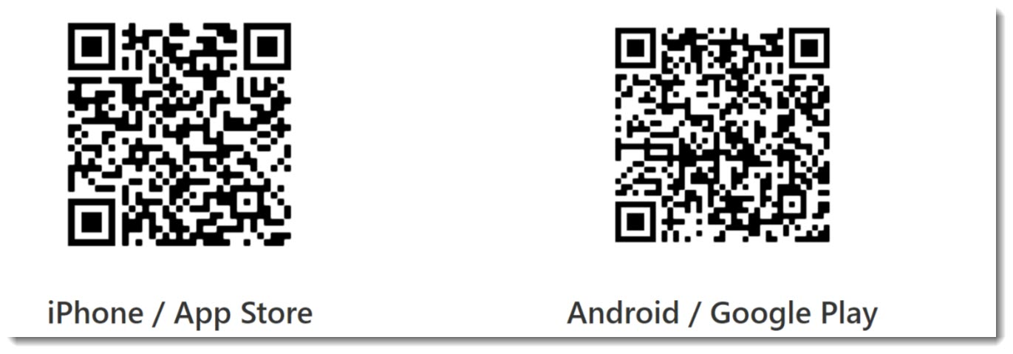

How do I access ACT 3 Site?
Then you're asked to enter your password or you can select I've forgotten my password to reset it.
You've already registered on ACT3’s site, use the email address you used to sign up to log into the app.

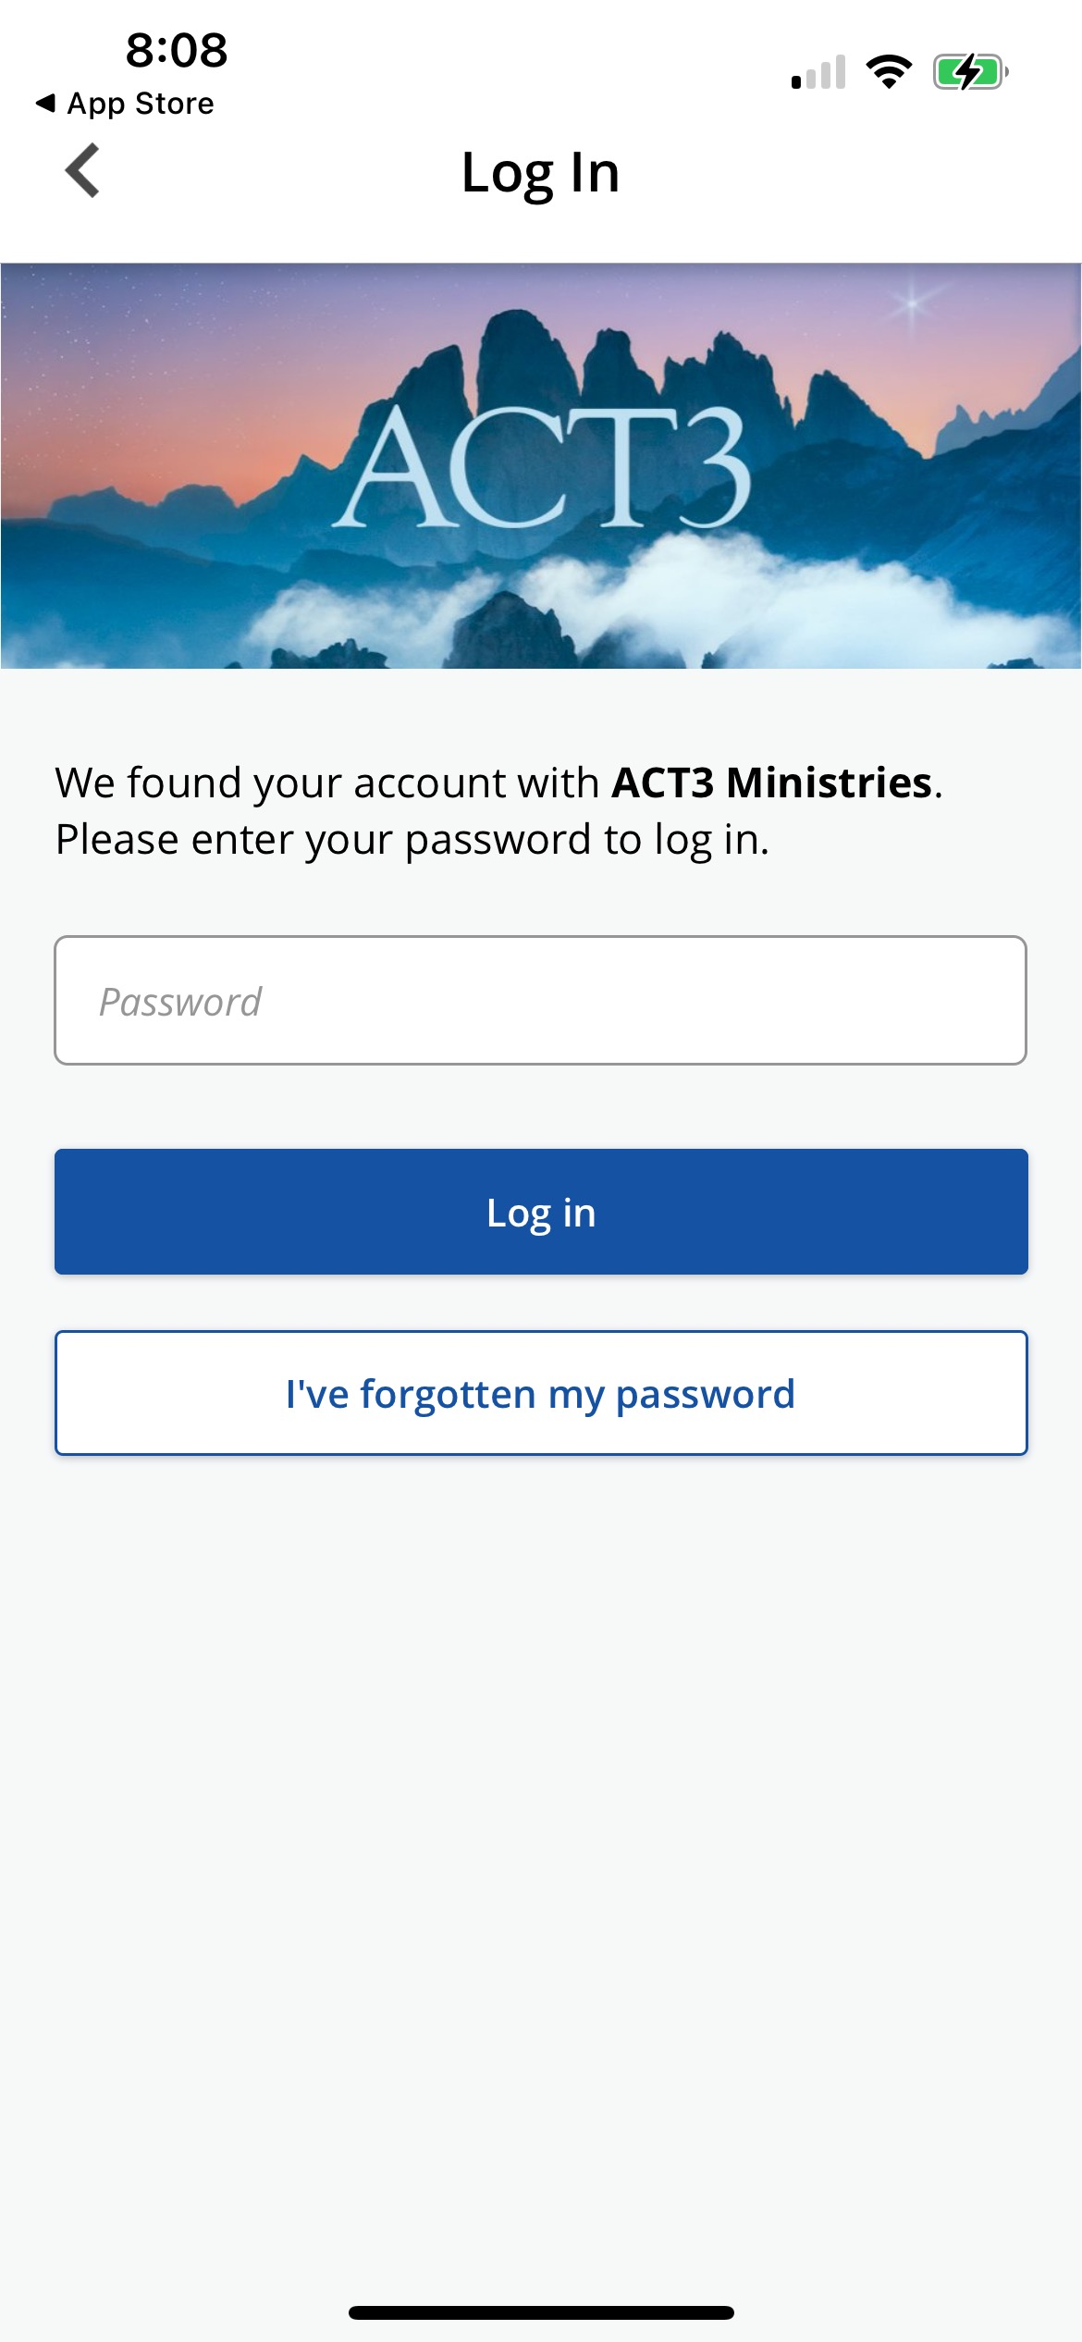
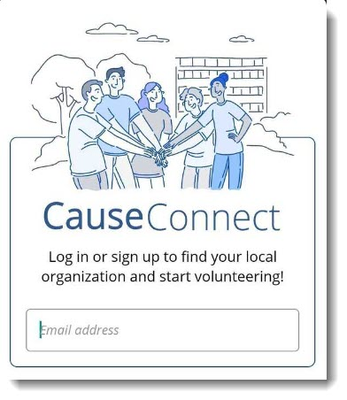
ⓘA popup you might encounter is a Push Notification Request. Turning this on allows you to receive important notifications from the app about your scheduled volunteer opportunities or other updates from the organization.

After logging in, you're taken to your volunteer dashboard where you can see your volunteer impact or search for volunteer opportunities!

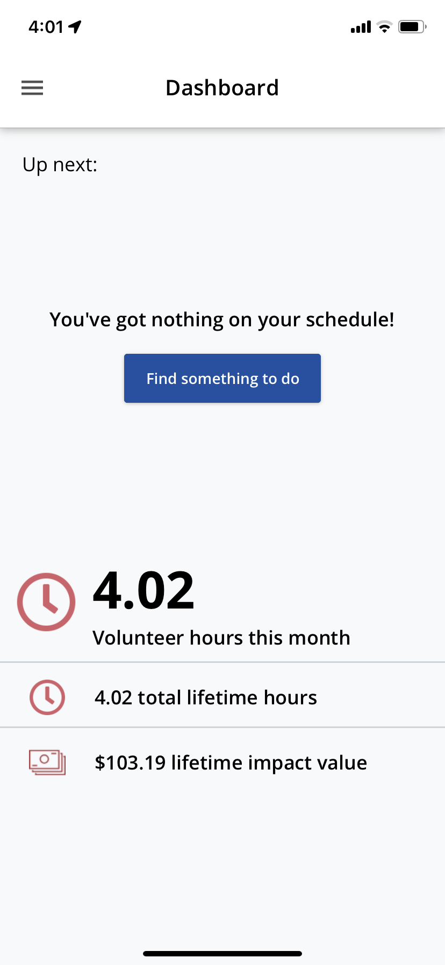

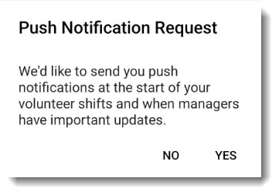

How do I find available opportunities?
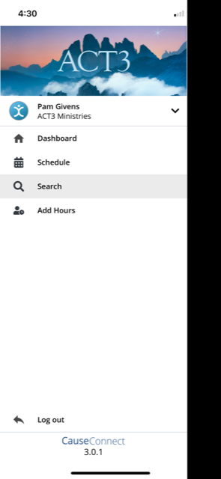
- From your dashboard, click Find something to do to start finding volunteer opportunities near you! Or You can also go to the Search area in the app by clicking the hamburger button (☰) in the top left of the app to open your menu.

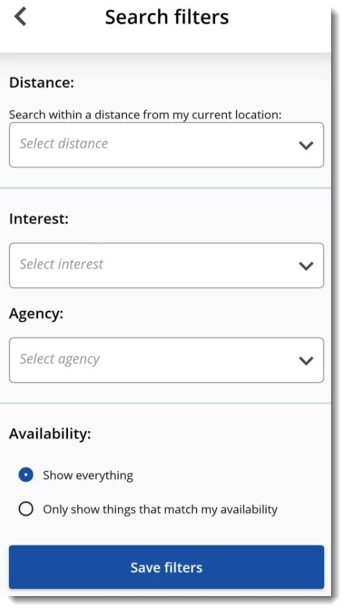
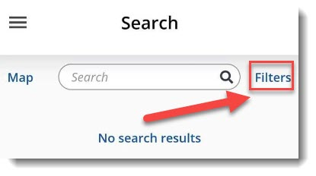
- To filter your search, click Filters and select Distance, Interest (Skill), or Agency (Program). It will save your filter parameters until you log out; therefore, to clear the filters you must log out.

How do I respond to an opportunity?
Clicking Respond opens the opportunity for you to view more details—click Respond again to confirm your selection.

After you filter your search and find the opportunity you want to respond to, click Respond.

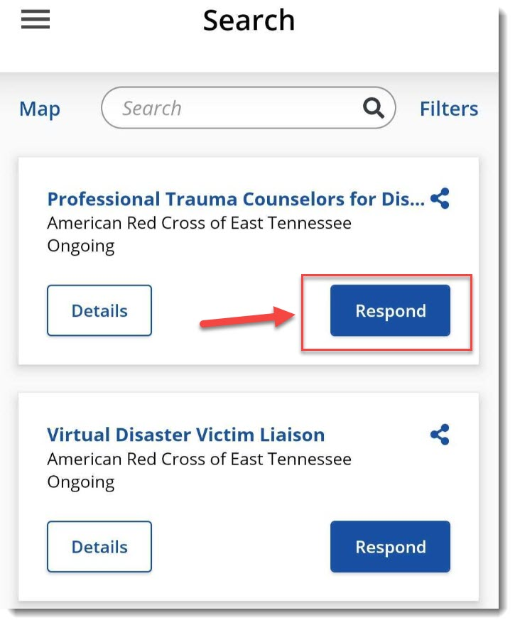
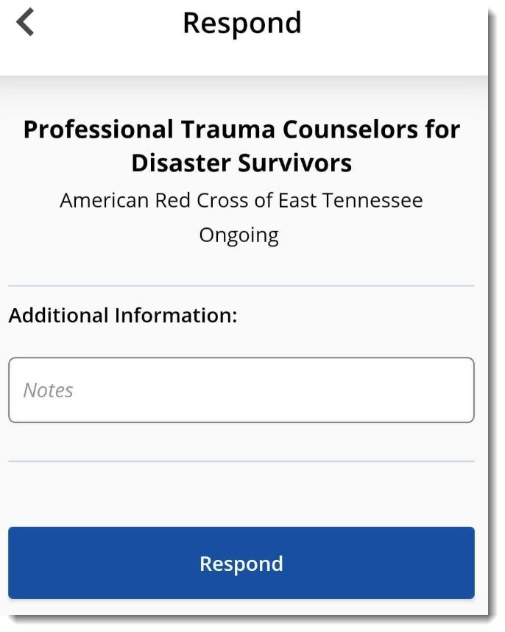

ⓘ So you know: You may encounter opportunities that require additional steps when responding to them—it just depends on the requirements for that opportunity.
How do I unregister for an opportunity?
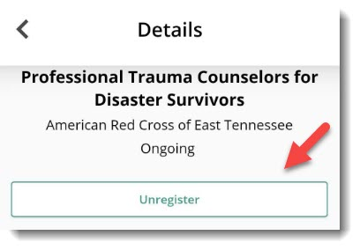
If you need to unregister for an opportunity,
click on it and select Unregister.

How do I check my schedule?
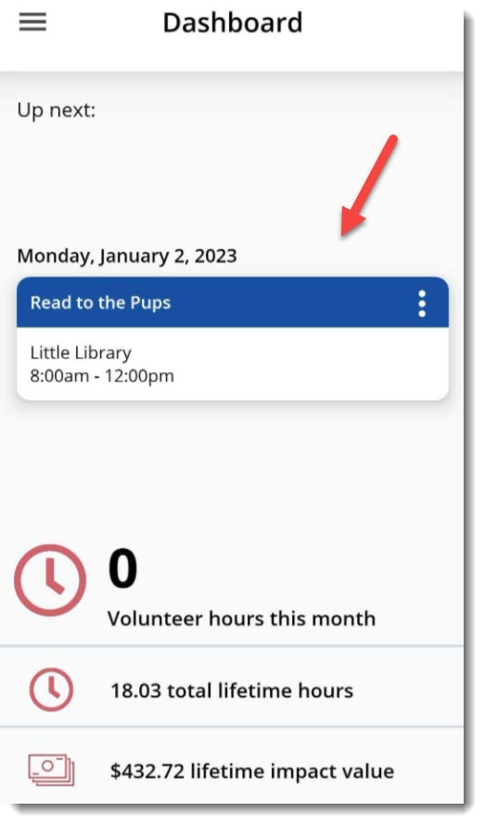
When you first enter the app, your dashboard shows
any upcoming volunteer opportunities that you're
scheduled for.

- If you want to see a calendar view of your schedule, click the hamburger button (☰) in the top left corner of the app and select Schedule from the menu.
From here, you can click on a date in the calendar to review details about that specific opportunity.
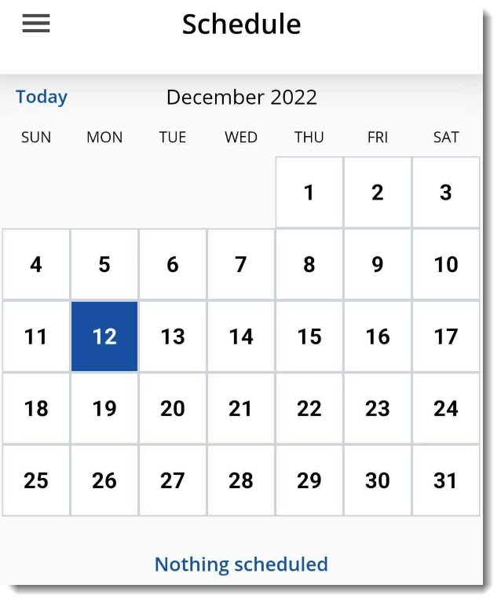
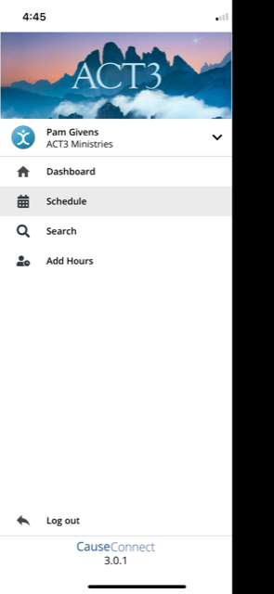

Remember to check-in or out of an opportunity!
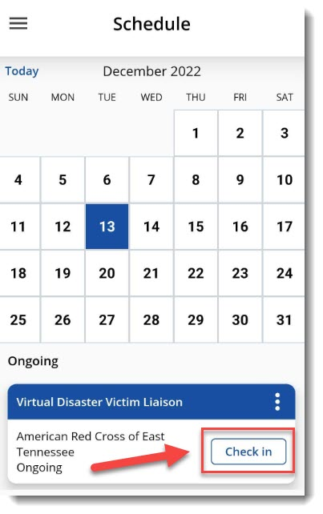
If you need to check in or out for an opportunity, go to the Schedule area in the app and click Check in then Check in again under the time stamp. To Check out, follow the same procedure.

How do I add hours?
If you need to add hours for an opportunity you volunteered for, then:
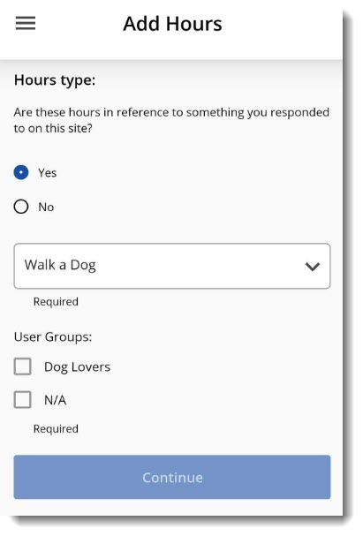
1. Click the hamburger button (☰) from the top left corner of the app and select Add Hours from the menu.
2. You must select the Hours type:
- For our opportunities you will respond to on the site, so select Yes.
3. If you selected yes for Hours type, then you must choose an opportunity from the dropdown menu.
4. If you completed the opportunity as a member in a User Group, select the User Group from the options.
- Select N/A if you weren't part of a User Group.
5. Click Continue.
6. Be sure to review your Hour Details and click Submit hours at the bottom

